(Approx. 269 words)

Back to Google Earth
By Len Nasman, Webmaster, Bristol Village Computer Club, OH
September/October issue, BVCC Newsletter
http://bvres.org/bvcchome.html
Webmaster (at) bvres.org
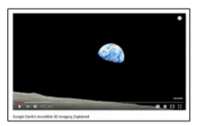
There seems to be no end to the global data base available through Google Earth. To start with, here is a link to a video that explains how Google Earth 3D images are created. I was surprised to learn that the 3D images of buildings are generated from pictures taken from airplanes.

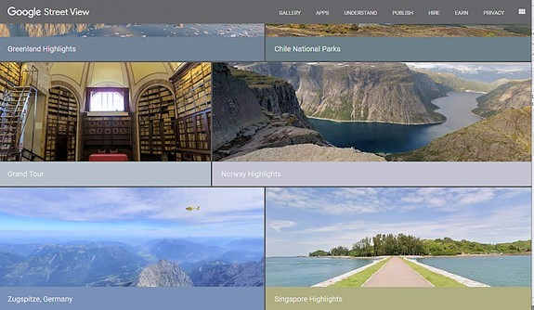
The Google Street View image collection continues to expand with pictures taken from cars, carts, back pack cameras, and even underwater cameras.

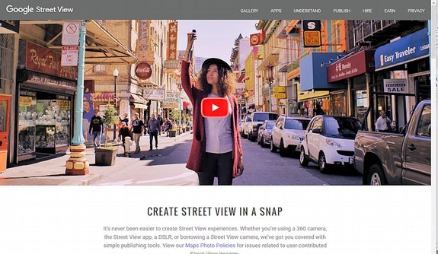
Now Google has increased their data collection efforts by allowing regular folks to add to the collection using something called Snap. You can take your own pictures and add them to the Google Earth database. You can even use 3D cameras (now available at consumer level prices) to add dynamic 360-degree views.
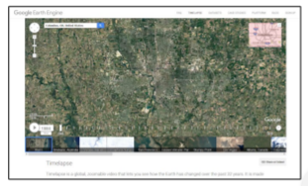

An interesting tool that has important implication for historical record keeping and scientific analysis is Google Timelapse. Using Google Earth Engine you can scroll through 22 years of aerial photos and see how the landscape of an area has changed. This is useful in everything from urban growth studies to glacial movement analysis to forest coverage studies.

I have looked at the Timelapse aerial photos of the woods I grew up in near Kane, PA, and found it a bit depressing. The area of our ‘secret fishing crick’ that used to require a several mile hike through unmarked forest has been destroyed by numerous oil wells and access roads. You might be amused by checking Timelapse photos of your places of interest.

